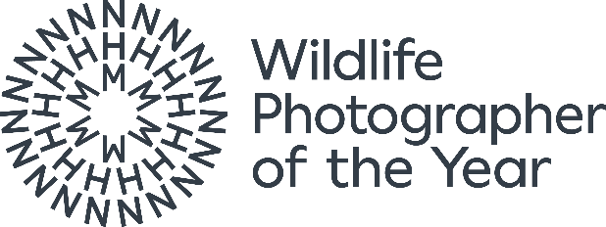

Terms and Conditions for Media

Please note that all coverage must include a link to our exhibition page. Please use this one: https://bit.ly/WPY61Exhibition

Conditions for all media governing use of Wildlife Photographer of the Year images
It is a fundamental condition of your use of these images that you comply with the terms in this document.
1. Background:
- We, the Natural History Museum Trading Company Limited, are delighted that the media organisation you represent wishes to publicise the Wildlife Photographer of the Year Competition and Exhibition.
- This document is a contract between us and the media organisation to which the images have been provided - it regulates how you may use images from the Competition and Exhibition.
- We do not own the copyright in the images - copyright is retained by the photographers themselves so it is crucially important that we ensure the images are used appropriately and all copyright is respected.
2. Permitted use. The images must:
- Be within articles / features where the dominant purpose is the promotion of the Competition and / or the Exhibition;
- Be used in good faith only;
- Not feature in articles / features that are of general interest or in articles / features where the subject matter of the photograph, and not the Competition or the Exhibition, is the main purpose behind the choice and use of the image;
- Be accompanied by as much content regarding the Competition, the Exhibition and the photographer as is reasonably possible;
- Conform to the highest standards of good taste and decency;
- Not bring us, the Competition, the Exhibition or the photographers into disrepute or ridicule;
- Comply with any reasonable guidelines that we publish from time to time regarding the use of or security of the images, including (for example) encryption and watermarking the images online.
3. Compulsory credits:
- “Wildlife Photographer of the Year is developed and produced by the Natural History Museum, London” must appear clearly and legibly in the editorial copy.
- “[Photographer’s name] / Wildlife Photographer of the Year” must appear clearly and legibly alongside the image.

4. Maximum number of images within a publication or website: Up to 16 (sixteen) images across multiple editions and pages unless otherwise agreed in writing between the publication and the Natural History Museum.
5. Provision of copies: A copy of any published content or access to any web pages incorporating any image must be supplied to us within 10 working days of publication.
6. Usage period: All copies of images you hold (or control) must be permanently destroyed after use. Archiving is only permitted online provided no further use of the images is made without consent.
7. Cropping and amendments: The images may not be cropped, overprinted or altered in any way without prior consent. Reasonable amendments and sensitive cropping may be accommodated with prior written approval.
8. Terms of use on the front cover of a publication:
(i) All front cover requests must be approved by the Natural History Museum and the photographer. The photographer must be contacted by the Natural History Museum for permission, and a fee may be requested. This is dependent on the photographer. The Natural History Museum cannot guarantee approval for the use of a particular image.
(ii) A proof copy must be provided to us (through the contact listed below) in advance of publication and no such use may be made without our prior written approval.

9. Legal Terms:
- This license to use the images has been granted to the organisation that has requested use of the images only: it may not be transferred to any third party without our prior written agreement. For the avoidance of any doubt, you are strictly prohibited from allowing any third party to use the images.
- You must notify us immediately of any unauthorised use of any of the images of which you become aware and provide us with reasonable assistance in identifying, locating and pursuing any such person for their unauthorised use.
- Neither we, nor the photographers, will be liable to you for any loss or damage suffered by you or by any third party arising from your use or reproduction of any image or related caption/credit.
- These conditions are governed by English law and the English courts shall have exclusive jurisdiction.
(v) In the event of your breach of these conditions then without prejudice to our other legal rights we reserve our right to require that you immediately cease use of the images; and / or you will be invoiced for the full commercial rate for use of each of the images.
For more information, please contact the Wildlife Photographer of the Year Communications Manager, Natural History Museum, Cromwell Road, London, SW7 5BD. Email: wildpress@nhm.ac.uk Tel: +44 (0)20 7942 5654.

